Neutron

Nova-compute Horizon Python / CLI APIs

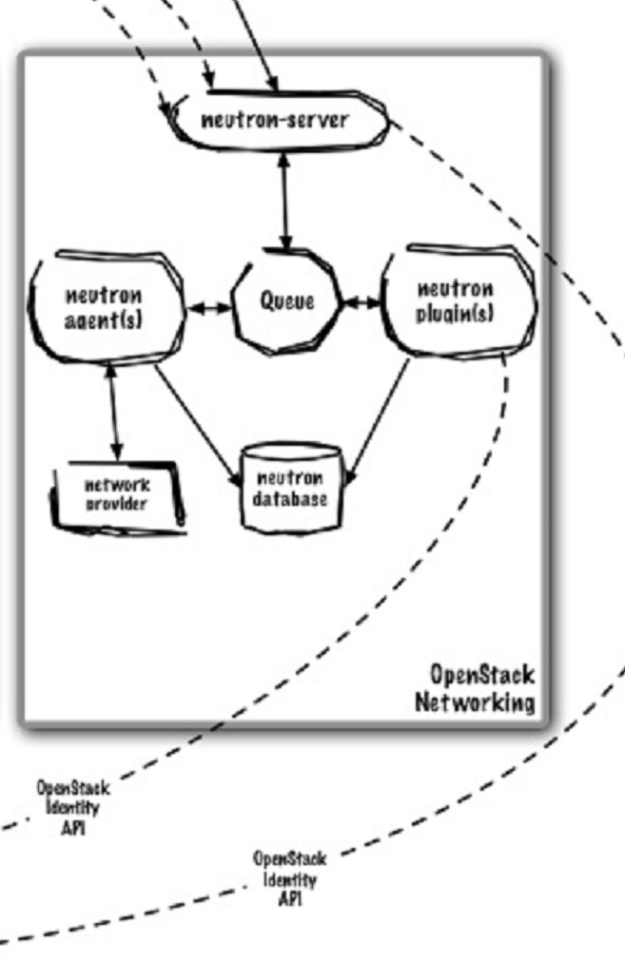 Keystone

Keystone

**neutron-server** - neutron-server provides a webserver that exposes the Neutron API, and passes all webservice calls to the Neutron plugin for processing.

4096 is the max number of VLANS you can have (Nova Network), Neutron can use GRE tunnels? Nova network was forked to create Neutron

**neutron-agents** – need help understanding this?

**neutron-plugins** – need help understanding this? -> 2 types, opensource and hardware vendors controlled plugins that requires hardware from vendors. Open vSwitch is the most popular.

**neutron-db** – need more info?

**queue** – same type of queue as in nova?

**neutron server (neutron-server and neutron-*-plugin)**

This service runs on the network node to service the Networking API and its extensions. It also enforces the network model and IP addressing of each port. The neutron-server and plugin agents require access to a database for persistent storage and access to a message queue for inter-communication.

**plugin agent (neutron-*-agent)**

Runs on each compute node to manage local virtual switch (vswitch) configuration. The plug-in that you use determine which agents run. This service requires message queue access. *Optional depending on plugin. Use to talk to Networking equipment.*

**DHCP agent (neutron-dhcp-agent)**

Provides DHCP services to tenant networks. This agent is the same across all plug-ins and is responsible for maintaining DHCP configuration. The neutron-dhcp-agent requires message queue access.

**L3 agent (neutron-l3-agent)**

Provides L3/NAT forwarding for external network access of VMs on tenant networks. Requires message queue access. *Optional depending on plug-in.*